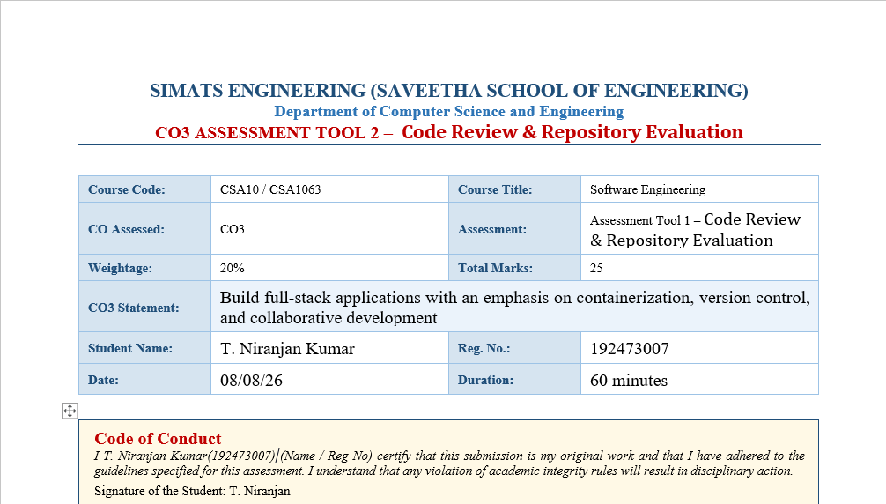
S. No. | Section | Page No.
1 | Problem Overview | 2
2 | Repository Organization | 4
3 | Code Quality Review | 5
4 | Version Control Evaluation | 6
5 | Code Testing and Validation | 8
6 | Repository Documentation | 10
7 | Code Review Evidence | 11
8 | Architecture and Component Interaction | 12
9 | Deployment and Runtime Validation | 13
10 | Code Review Findings and Recommendations | 14
11 | Conclusion and References | 15
1. Problem Overview
Question 1 – Problem overview and implemented solution
The Open-Source Contribution Tracker is a web-based application intended to help beginner developers identify suitable open-source issues and view contribution information. The implemented prototype uses a Flask backend, a browser-based frontend, a recommendation module, and contribution data.

Key objectives
• Recommend suitable issues based on programming skills entered by the user.
• Provide a simple dashboard for recommendations and contribution tracking.
• Return contribution information through a backend API.
• Keep the project separated into understandable modules so that individual parts can be maintained and reviewed.

Key functionalities
• Skill-based issue recommendation.
• Contribution data retrieval through the API.
• Browser dashboard using HTML, CSS and JavaScript.
• Flask routes for serving the application and API responses.
• Containerized execution using Docker.

Review observation
The implemented prototype directly demonstrates the main workflow required by the project: the user interacts with the dashboard, the backend processes requests, and the application returns recommendation or contribution data.
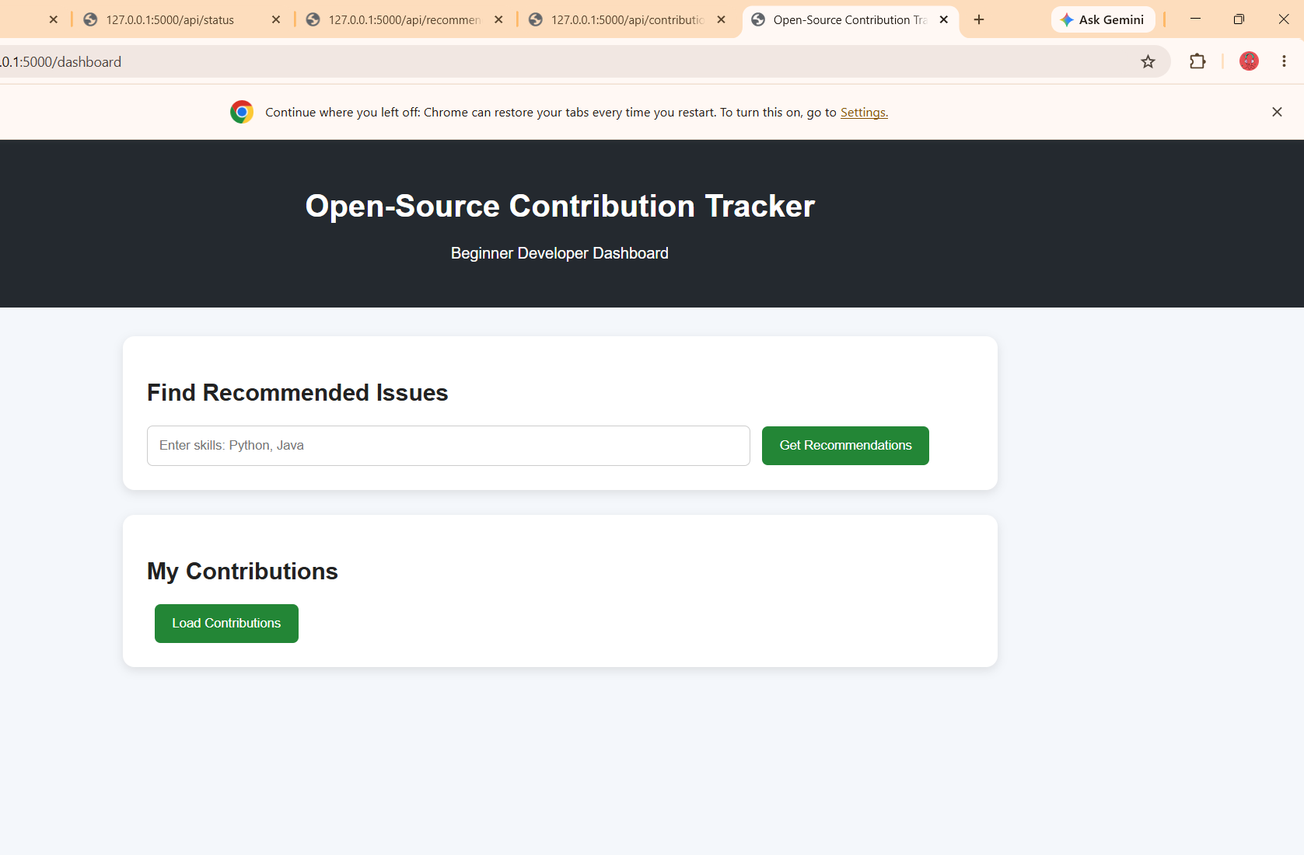
Figure 1. Implemented Open-Source Contribution Tracker dashboard.
2. Repository Organization
Question 2 – Folder organization and naming conventions
The repository is organized into separate functional areas. This separation makes the code easier to locate, review and modify. The main project areas are backend, frontend, database and recommendation.
Component | Main files | Review purpose
backend | app.py, requirements.txt | Flask routes, request handling and dependencies
frontend | index.html, style.css, script.js | User interface and browser-side behaviour
recommendation | recommend.py | Recommendation filtering logic
database | contributions.py | Contribution data handling

Maintainability assessment
• The folder names clearly indicate their responsibilities.
• The separation of frontend and backend reduces unnecessary coupling.
• The recommendation logic is kept outside the main Flask file, improving modularity.
• The dependency file is kept with the backend, making environment setup easier.
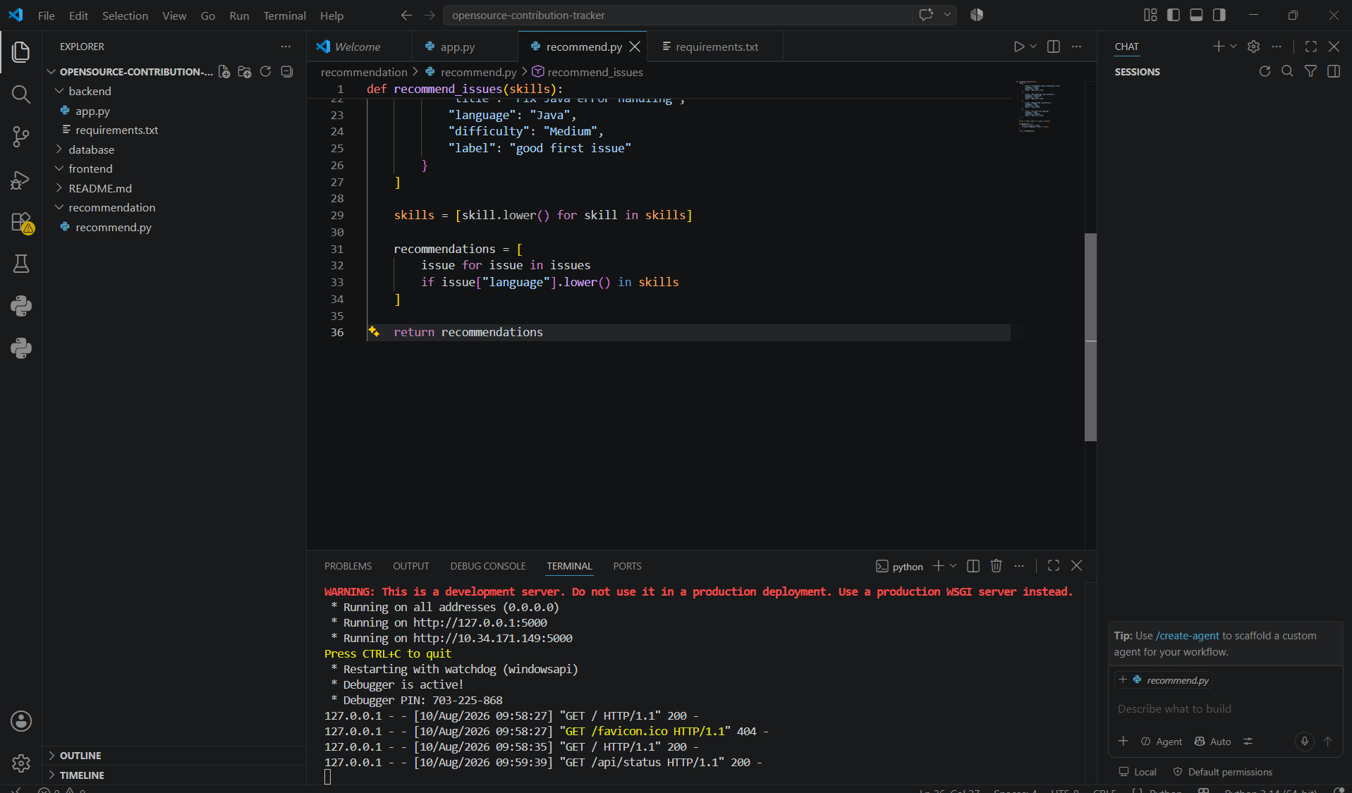
Figure 2. Repository and source-code view used during the implementation review.

3. Code Quality Review
Question 3 – Readability, modularity, standards and maintainability
The source code was reviewed with focus on readability, modularity, naming, separation of responsibilities and ease of maintenance.
Review area | Observation | Assessment
Readability | Functions and routes are short and the overall flow is easy to follow. | Good
Modularity | Recommendation and contribution logic are separated from the main application. | Good
Naming | Names such as recommend_issues, get_contributions and dashboard are descriptive. | Good
Documentation | The code is understandable, but more inline comments and module-level documentation could be added. | Needs improvement
Maintainability | Separate modules make future changes easier without modifying the complete application. | Good

Strengths identified
• Clear separation between the Flask application and recommendation logic.
• Frontend assets are separated into HTML, CSS and JavaScript files.
• API routes have focused responsibilities.
• The code is small enough to understand and test quickly.

Areas for improvement
• Add concise comments where the purpose of non-obvious logic is not immediately clear.
• Use a more structured configuration approach for production settings.
• Add automated unit tests for recommendation and API functions.

4. Version Control Evaluation
Question 4 – Git history, branches, commit messages and maintenance
Git was used to maintain the project source code and development history. The repository contains separate feature branches for backend, frontend, recommendation and Docker-related work.

Observed practices
• The repository contains a main/master branch and feature branches.
• Feature branches isolate work related to different project components.
• The initial project setup is recorded in the commit history.
• The commit history provides traceability for repository changes.

Collaboration value
A feature-branch workflow allows changes to be developed independently before integration. This makes the repository easier to review and reduces the risk of unrelated changes being mixed together.
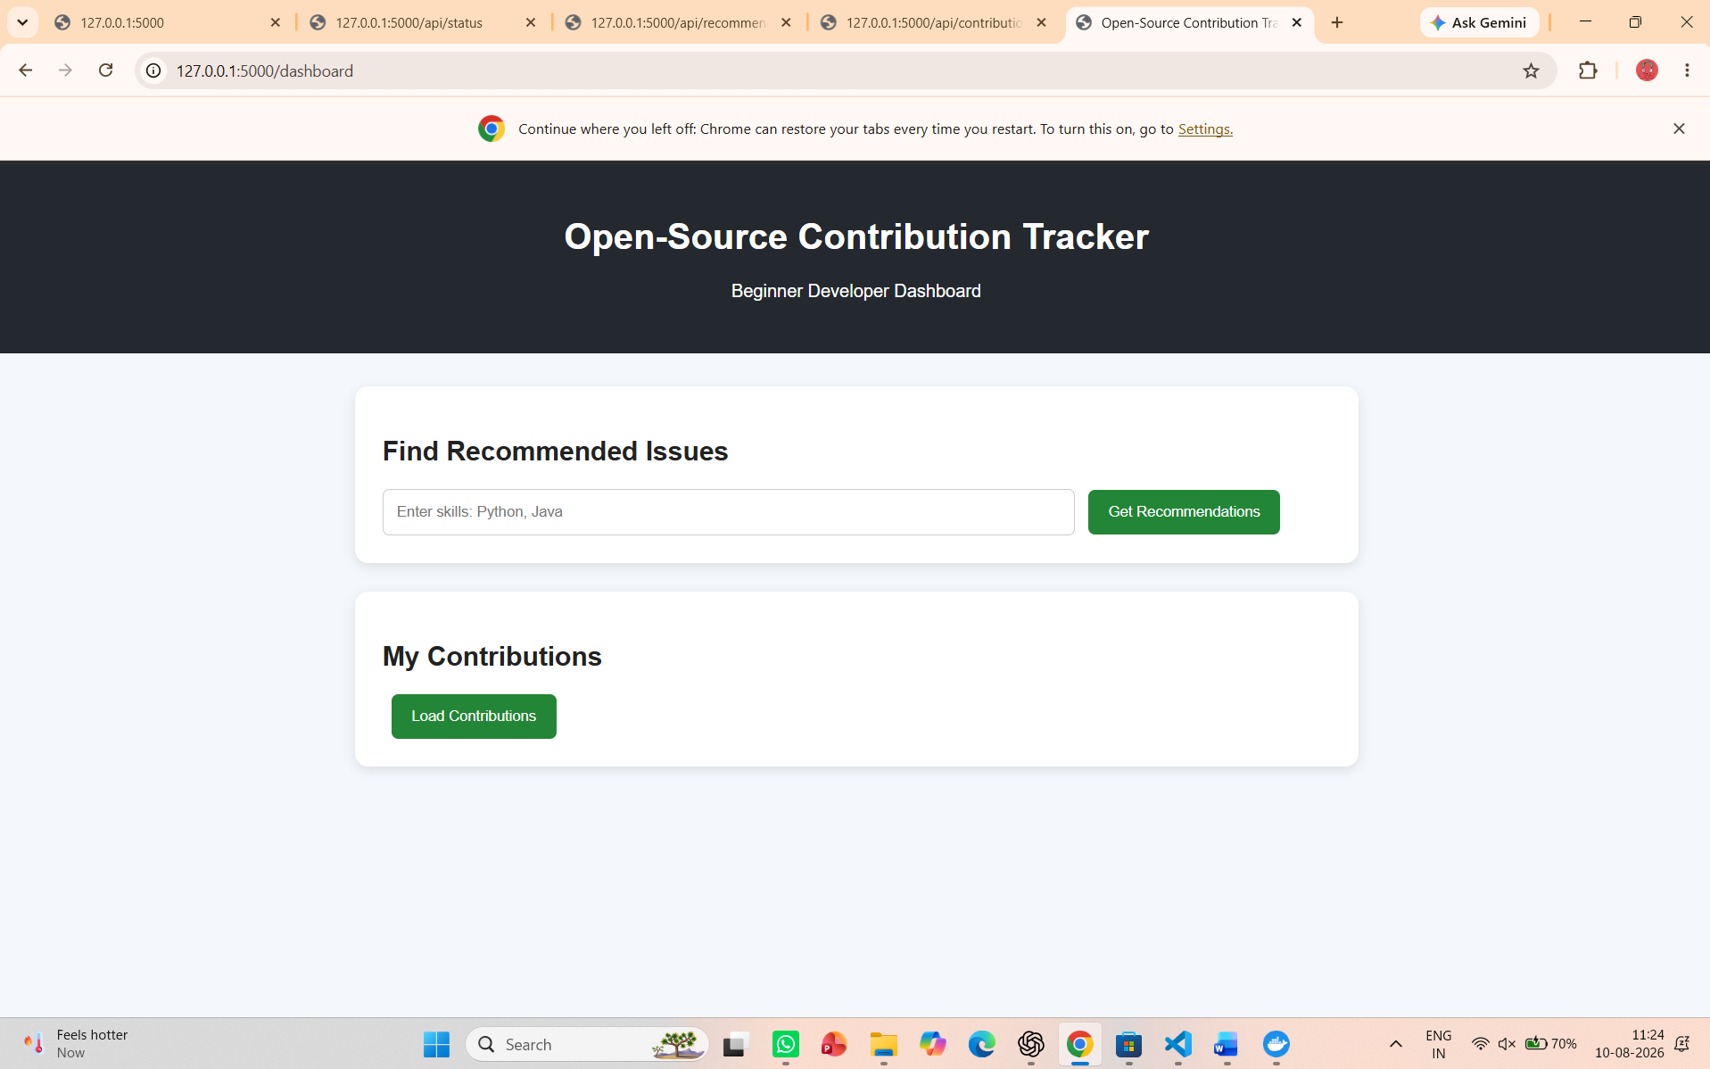
Figure 3. Git and project terminal evidence captured during repository development.
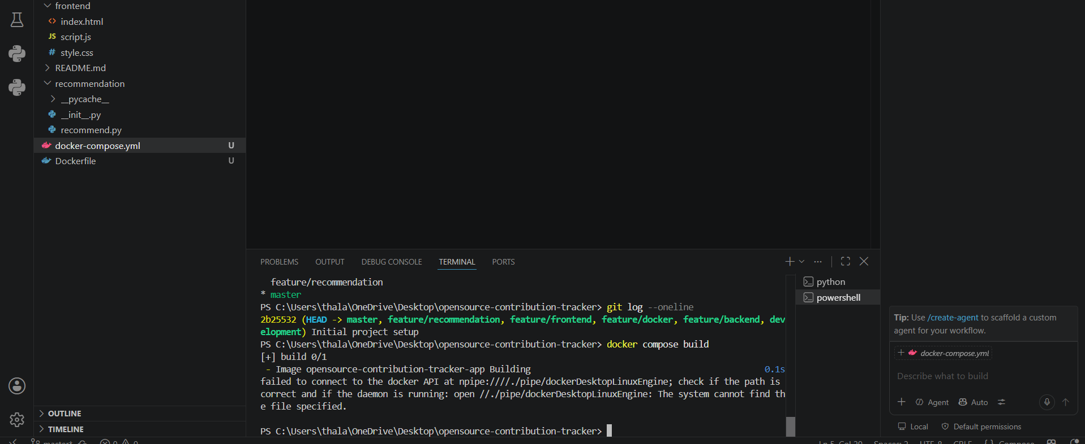
Figure 4. Project workspace and development environment during execution.

5. Code Testing and Validation
Question 5 – Test execution, results and evidence
Testing was performed by running the application and checking the browser dashboard and backend endpoints. The evidence shows successful application execution and contribution data returned in JSON format.
Test case | Expected result | Observed result
Application startup | Flask application starts without runtime failure. | Successful
Dashboard access | Dashboard loads in the browser. | Successful
Contribution API | API returns contribution records as JSON. | Successful
Docker build | Docker image is created successfully. | Successful
Docker Compose | Container starts and exposes the application on port 5000. | Successful
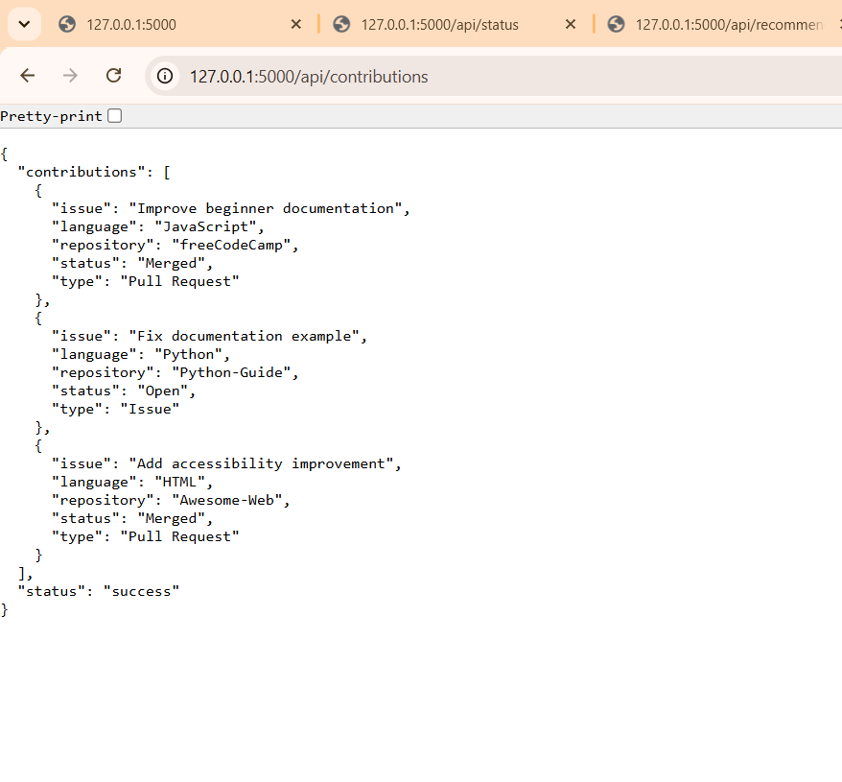
FigureContribution API response showing returned contribution records.
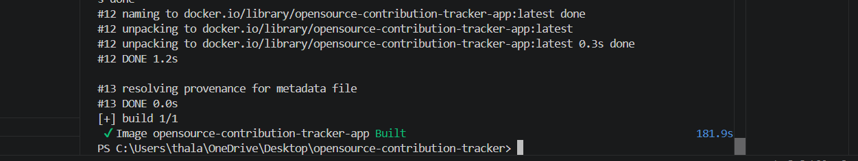
Figure 6. Successful Docker image build.

6. Repository Documentation
Question 6 – README, dependencies, installation and usage
The repository includes a README and a dependency file. The project structure separates the application code from supporting configuration, making the setup information easier to maintain.

Documentation review
• README is present in the project repository.
• requirements.txt records the Python dependencies required by the backend.
• The dashboard provides an identifiable user flow for recommendations and contribution loading.
• Dockerfile and docker-compose.yml provide deployment configuration.

Suggested documentation improvements
• Add a short installation section with the exact commands required to run locally.
• Document the main API endpoints and sample responses.
• Add a brief troubleshooting section for common Docker or dependency errors.
• Keep setup instructions synchronized whenever dependencies or routes change.
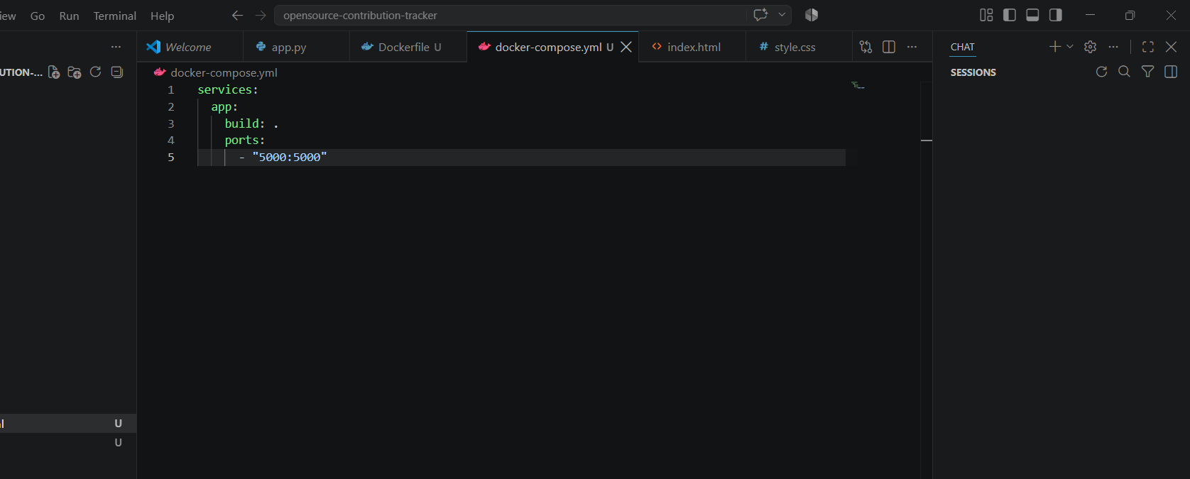
Figure 7. Docker Compose configuration present in the project.

7. Code Review Evidence
Screenshots from the implemented project
The following evidence is taken from the working project screenshots supplied for this assessment. No additional or unrelated screenshots are included.
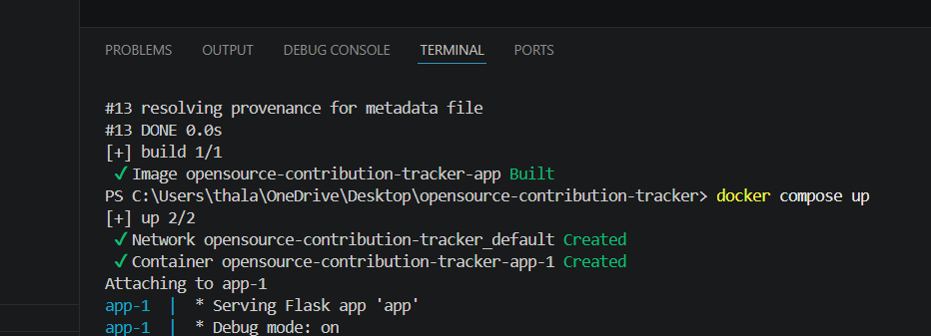
Figure 8. Docker Compose startup and container creation.
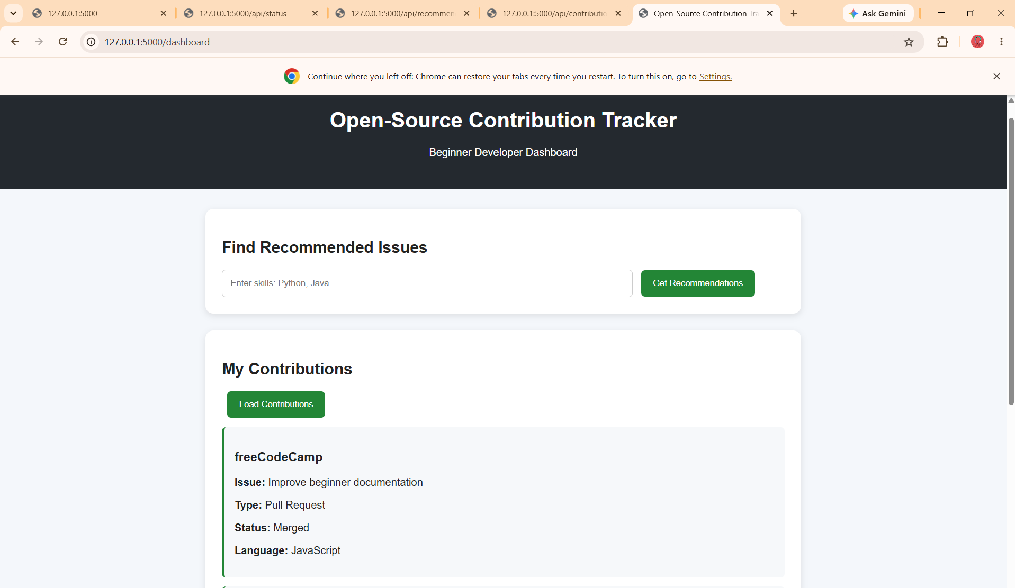
Figure 9. Dashboard showing the contribution section after loading data.

8. Architecture and Component Interaction
System-level view used for the code review
The system follows a simple frontend-backend structure. The browser communicates with the Flask backend, which connects the recommendation and contribution modules. Docker provides the execution environment.

Component interaction
• User → browser dashboard: enters skills or requests contribution data.
• Frontend → Flask API: sends HTTP requests.
• Flask → recommendation module: processes skill-based recommendations.
• Flask → contribution module: obtains contribution records.
• Docker → application runtime: packages and runs the application consistently.
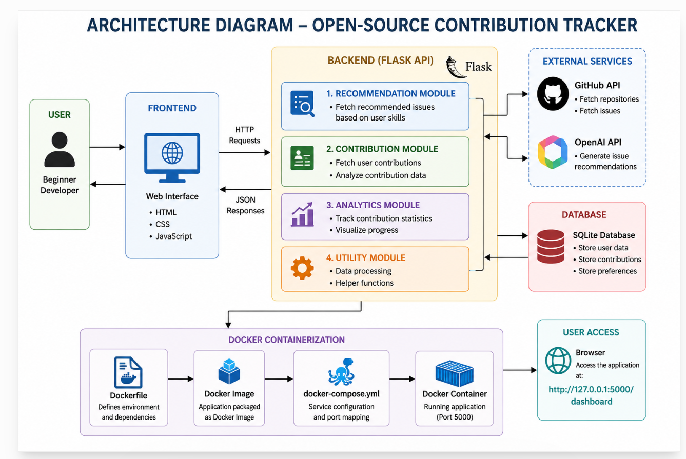
Figure 10. Architecture diagram of the Open-Source Contribution Tracker.

9. Deployment and Runtime Validation
Container execution evidence
The project was containerized using Docker. The Dockerfile defines the Python environment, installs the required dependencies and starts the Flask application. Docker Compose is used to build and start the application service.

Deployment observations
• The Docker image was built successfully.
• Docker Compose created the application network and container.
• The Flask application started inside the container.
• Port 5000 was mapped for browser access.
• Docker Desktop showed the running application container.
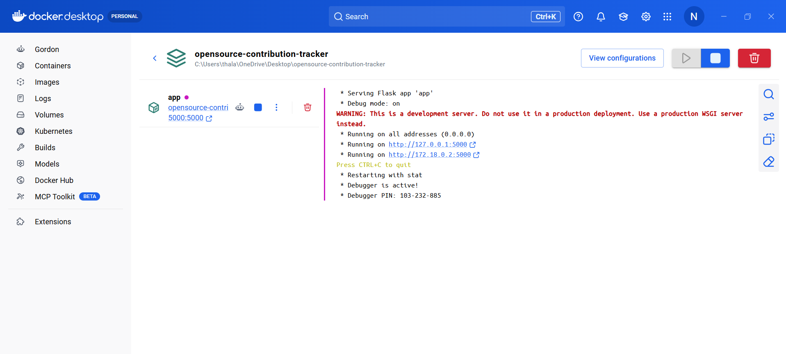
Figure 11. Running application container shown in Docker Desktop.

10. Code Review Findings and Recommendations
Question 7 – Overall findings and practical improvements

Overall findings
• The project has a clear separation of frontend, backend, recommendation and contribution-data responsibilities.
• The source code is compact and readable enough for a beginner-level project.
• The repository structure supports independent work on different components.
• Git history and feature branches provide a useful development trail.
• The application was validated through browser and API execution.
• Docker provides a repeatable environment for running the application.

Recommendations
Area | Recommended improvement
Code quality | Add unit tests and concise comments for important logic.
Repository | Add a standard .gitignore and keep generated files such as __pycache__ out of commits.
Version control | Use clear conventional commit messages for future changes.
Documentation | Document setup, API endpoints and troubleshooting steps.
Testing | Automate basic API and recommendation tests before integration.
Deployment | Use environment variables for production configuration and secrets.

11. Conclusion and References
The Open-Source Contribution Tracker was successfully developed as a full-stack application to help beginner developers identify suitable open-source issues based on their programming skills and track contribution-related information. The project integrates a Flask-based backend with a frontend developed using HTML, CSS and JavaScript. The application also separates recommendation and contribution-handling logic into independent modules, making the system easier to understand, review and maintain. Git was used for version control and feature-based development, while Docker and Docker Compose were used to provide a consistent execution environment.
The code review and validation of the project demonstrate the practical application of important software engineering practices such as modular design, code readability, repository organization, version control, testing and containerization. The application was successfully validated through the dashboard, API responses, Docker image build and container execution. However, further improvements can be made by adding automated unit tests, improving documentation, removing generated files from the repository, using clearer commit conventions and strengthening production configuration. These improvements can make the system more reliable, maintainable and suitable for future development.

References
1. McIntosh, S., Kamei, Y., Adams, B., & Hassan, A. E. (2016). An empirical study of the impact of modern code review practices on software quality. Empirical Software Engineering, 21(5), 2146–2189.
DOI: https://doi.org/10.1007/s10664-015-9381-9
2. Fitzgerald, B., & Stol, K.-J. (2017). Continuous software engineering: A roadmap and agenda. Journal of Systems and Software, 123, 176–189.
DOI: https://doi.org/10.1016/j.jss.2015.06.063
3. Spadini, D., Palomba, F., Baum, T., Hanenberg, S., Bruntink, M., & Bacchelli, A. (2019). Test-Driven Code Review: An Empirical Study. Proceedings of the 41st IEEE/ACM International Conference on Software Engineering (ICSE), 1061–1072.
DOI: https://doi.org/10.1109/ICSE.2019.00110
4. AlOmar, E. A., Chouchen, M., Mkaouer, M. W., & Ouni, A. (2022). Code review practices for refactoring changes: An empirical study on OpenStack. Proceedings of the 19th ACM/IEEE International Conference on Mining Software Repositories (MSR), 689–701.
DOI: https://doi.org/10.1145/3524842.3527932
5. Charoenwet, W., Thongtanunam, P., Pham, V.-T., & Treude, C. (2024). Toward effective secure code reviews: An empirical study of security-related coding weaknesses. Empirical Software Engineering, 29(4), Article 88.
DOI: https://doi.org/10.1007/s10664-024-10496-y.

